Employee Salary Management – Java Program

Question
Write a Java program using an abstract class Employee to demonstrate abstraction, inheritance, method overriding, and runtime polymorphism. Create RegularEmployee, ContractEmployee, and Vendor classes. Based on the employee ID entered by the user, display the appropriate salary details.

Execution Steps
Step 1: Start the program.
Step 2: Import Scanner for keyboard input.
Step 3: Create abstract class Employee with empId and abstract method displaySalaryDetails().
Step 4: Create RegularEmployee, ContractEmployee, and Vendor by extending Employee.
Step 5: Override displaySalaryDetails() in each derived class.
Step 6: Read the employee ID from the user.
Step 7: Check the starting letter of the ID.
Step 8: If the ID starts with R, create RegularEmployee. Step 9: If the ID starts with C, create ContractEmployee. Step 10: Otherwise, create Vendor.
Step 11: Store the selected object in Employee reference emp.
Step 12: Call emp.displaySalaryDetails().
Step 13: Display the result, close Scanner, and stop.

Algorithm
  - Start.
  - Define abstract class Employee with empId and displaySalaryDetails().
  - Define RegularEmployee, ContractEmployee, and Vendor classes.
  - Override displaySalaryDetails() in all derived classes.
  - Read employee ID.
  - If ID starts with R, create RegularEmployee.
  - Else if ID starts with C, create ContractEmployee.
  - Else create Vendor.
  - Store the object in an Employee reference.
  - Call displaySalaryDetails().
  - Display salary details or vendor message.
  - Stop.

4)UML Diagram :

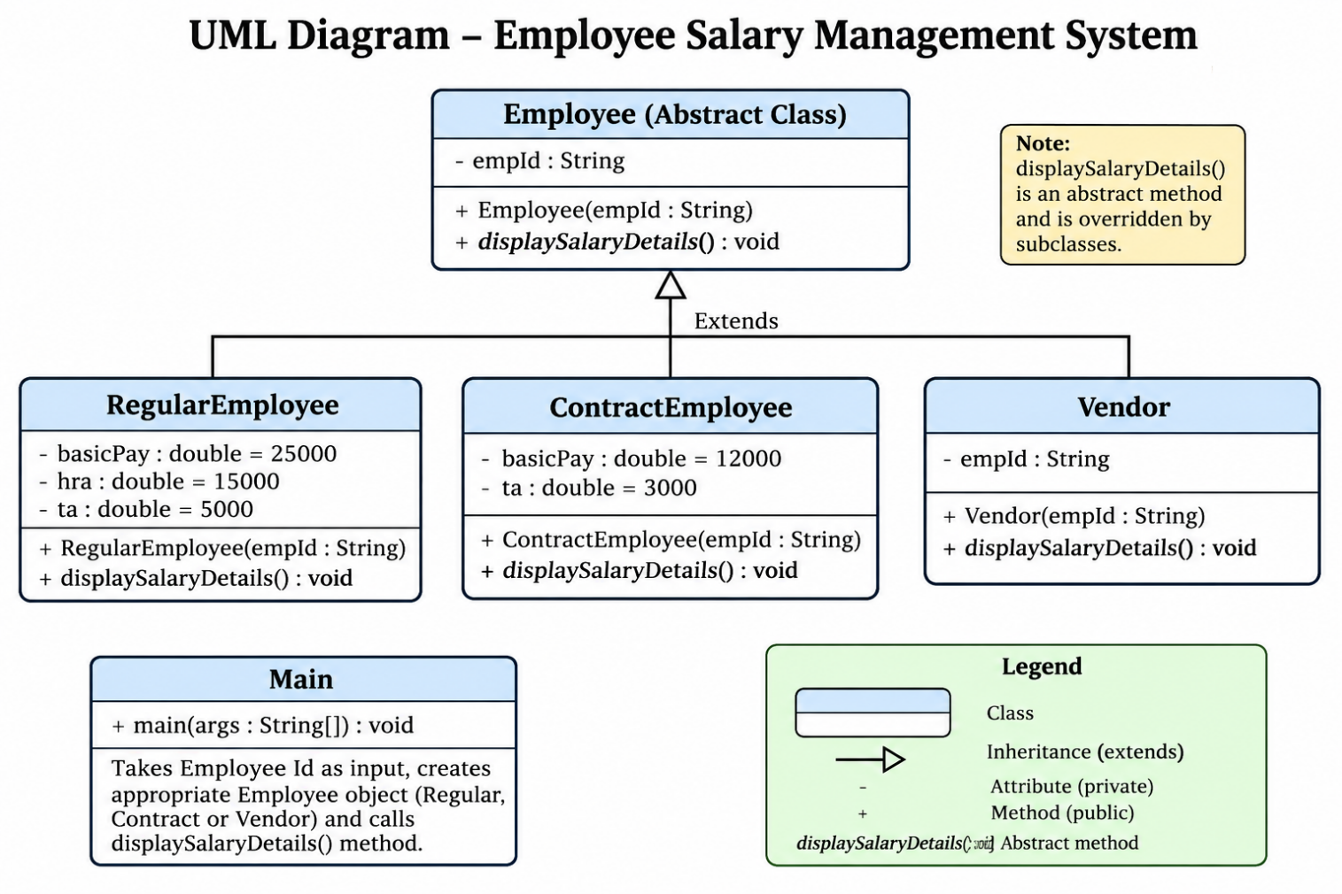

5)Java Source Code :

Import.java.util.Scanner;
abstract class Employee {
String empId;

Employee(String empId) { this.empId = empId;
}

public abstract void displaySalaryDetails();
}

class RegularEmployee extends Employee { private double basicPay = 25000; private double hra = 15000;
private double ta = 5000;

RegularEmployee(String empId) { super(empId);
}

@Override
public void displaySalaryDetails() { double total = basicPay + hra + ta; System.out.println("Salary Details:");
System.out.println("Basic Pay: " + basicPay); System.out.println("HRA: " + hra); System.out.println("T.A: " + ta); System.out.println("Total Amount: " + total);
}
}

class ContractEmployee extends Employee { private double basicPay = 12000; private double ta = 3000;

ContractEmployee(String empId) { super(empId);
}

@Override
public void displaySalaryDetails() { double total = basicPay + ta; System.out.println("Salary Details:");
System.out.println("Basic Pay: " + basicPay); System.out.println("T.A: " + ta); System.out.println("Total Amount: " + total);
}
}

class Vendor extends Employee { Vendor(String empId) {
super(empId);
}

@Override
public void displaySalaryDetails() {
System.out.println("Vendors are not part of payroll system.");
}
}

public class Main {
public static void main(String[] args) { Scanner sc = new Scanner(System.in);

System.out.print("Enter Employee Id: "); String empId = sc.nextLine();

Employee emp;

if (empId.startsWith("R")) {
emp = new RegularEmployee(empId);
} else if (empId.startsWith("C")) { emp = new ContractEmployee(empId);
} else {
emp = new Vendor(empId);
}

emp.displaySalaryDetails(); sc.close();
}
}

6)Output - Terminal ScreenShot :

